Passive First order RC Filters

Low pass filter

Methodology
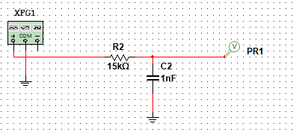
Figure shows a passive RC low pass filter. The values of the components were chosen because they match with circuit #1 of the D3000 board, “filters”.

Results & Analysis

High pass filter

Methodology

Results & Analysis

Active Second order Sallen-Key filters

Low pass filter

Methodology

Results & Analysis

High pass filter

Methodology

Results & Analysis

low pass filter with mid-band gain of 3

Methodology

Results & Analysis

More complex filters

Fourth order low pass Sallen-key filter

Methodology

Results & Analysis

Second order band-pass Sallen-key filter

Methodology

Results & Analysis

Second order band-reject Sallen-key filter

Methodology

Results & Analysis

